A close up of a sign

Description generated with high confidence

**Littlemax Promotion**

**Scottish United Farmers Group Member Offer**

Buy 1 Pallet of 42 Littlemax and get 4 Bales Free

**Scottish Customer Offer**

Buy 10 Bales of Littlemax and get 1 Bale Free

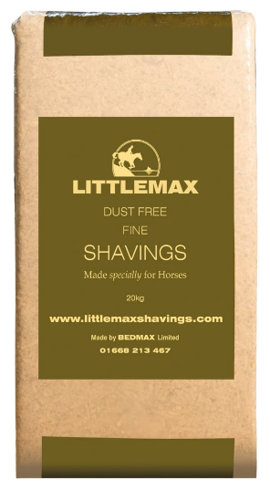I would also like to confirm the price per bale of Littlemax out of the Greymare Plant is now reduced to £4.50. This is a reduction of 15p per bale. Please do not hesitate to contact Liz Smith on 07734 953 043 if you have any questions on the above.